COMPANY PROFILE


Global Infoventures is a dynamic emerging IT Product & Services company with its major interest in Education, Energy & Insurance sectors, Education being its major focus. The company aims at converging high-end technology and innovative ideas to create best possible technology solutions.
In the midst of a technology revolution led by Artificial Intelligence (AI), Global Infoventures has partnered with NVIDIA, the pioneer in Artificial Intelligence, Machine Learning & Computational Science. Globally NVIDIA Platforms are being used for large & complex applications in Aerospace, Cyber security, Engineering, Healthcare, Manufacturing, Robotics & Research etc.
EDUCATION OFFERRINGS
A. G5 PLATFORM & SIM
G5 platform is a comprehensive digital platform for the entire education-ecosystem. The platform provides 24x7 global access through its cloud-based system and a variety of services to all stakeholders - students, parents, faculty, staff, administration and top management. With its sterling dashboards and business intelligence, it helps in efficient decision making based on real-time information on all aspects of academic, financial and institutional processes.
SIM, the core engine of G5 platform, consists of an integrated database along with function modules. It intelligently integrates and facilitates query handling, core information processing and smooth interfacing with other G5 applications. Further, it seamlessly inter-connects different functional modules of an educational setup, catering to
- Student Life Cycle Management
- Employee Management
- Academic Management
- Financial Management
- Institutional Management

B. AIMS
IMS AIMS (Admission Information Management Solution) is a solution which automates the entire Admission Life Cycle converging Online Applications, Telephonic enquiries and Walk-Ins using its CRM, Call Centre Solution and Centralized Admission Cell. It is a comprehensive solution, which offers a strong real-time, business analytics for making right, strategic decisions.
AIMS helps in identifying, engaging and converting prospective candidates for admission into an institution. It helps in personalizing communications through its Call Centre, SMS and email services to ensure that the right message gets across. This automation of Admission Life Cycle, with real-time picture, works as a big boon in aligning activities. Having focused admission approach and fast decision making ultimately leads to a process that drives results and maximizes admission goals.
C. NVIDIA’s AI Centre of Excellence
Institutions need to meet the demand for a flexible, accessible education options for AI and Deep Learning. NVIDIA's AI Centre of Excellence, an AI infrastructure solution developed from the experience of thousands of nodes of leading-edge accelerated computing deployed in the world’s largest research environments, helps in adoption of scalable AI by educational institutions.
Starting from optimized infrastructure, systems and tools to build, validate, and deploy AI, NVIDIA's AI Centre of Excellence offers solutions based on a common set of tools and frameworks that scale with the needs of different educational Institutions.

Company Details Global Infoventures Pvt. Ltd.
H-65, Sector-63, Noida- 201301
Website https://www.giindia.com/
TRAINING CERTIFICATE
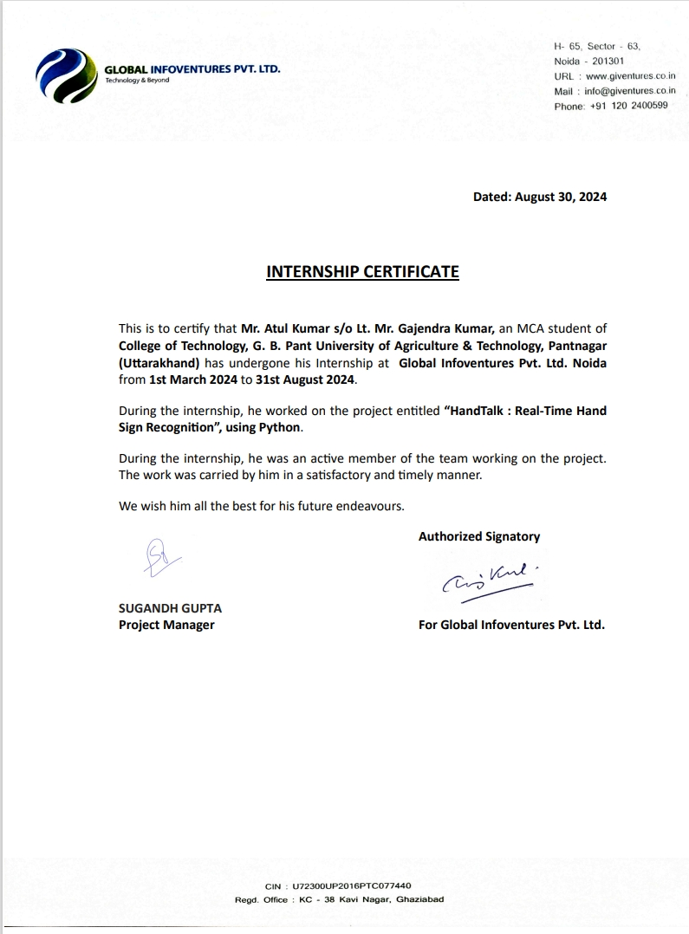
CURRICULUM VITAE

Name | : | Mr. Atul Kumar | Phone Number | : | 8191947104
Mailing Address | : | Vill- Bajeti, PO- Degree College, Pithoragarh | Permanent Address | : | Vill- Bajeti, PO- Degree College, Pithoragarh
E-mail | : | atulkumarakku@gmail.com
Career Objective | : | AI Developer
Educational Qualification | :

Sr. No. | Examination Passed | Institution | Year | Percentage/CGPA
1. | M.C.A. | GBPUA&T., Pantnagar, Uttarakhand | 2024 | Pursuing
2. | B.C.A. | Kumaun University, Nainital | 2021 | 78 %
3. | Intermediate | G.I.C. Kanalichhina, Pithoragarh | 2018 | 68.4 %
4. | High School | G.I.C. Kanalichhina, Pithoragarh | 2016 | 76.6 %

Specialization: Major: Computer Applications Minor: Nil
Publication: Nil
Conference/Seminars/Workshops/Training Attended: Nil
List of papers presented in conference/seminar during degree programme: Nil
Software Skills: Python, C++, Java, OOPS, ReactJS, Deep Learning, Artificial Intelligance
Professional Skills: Worked as an Intern at Global Infoventures Private Limited
Professional Affiliations (Membership, etc.,): Nil
Awards/Honours/Achievements: Nil

Place: Pantnagar
Date: (Atul Kumar)

Name | : |  | Atul Kumar | Id. No. | : | 58042
Semester & | : |  | I, 2021-2022 | Degree | : | MCA
Year of admission
Department | : | Department of MCA Programme, College of Technology
Major | : |  | Master of Computer Applications
Industrial Training / Project  Title | : | HandTalk: Real-Time Hand Sign Recognition
No. of pages | : | 53 |  | Advisor | : | Dr. Shri Prakash Dwivedi

ABSTRACT

Communication barriers between individuals who use American Sign Language (ASL) and those who do not remain a significant challenge. There is a lack of effective tools that allow real-time translation of hand signs into text or speech, making communication difficult for people with hearing and speech impairments. To address this problem, we developed “HandTalk: Real-Time Hand Sign Recognition”, a deep learning-based desktop application that recognizes ASL gestures and translates them into text and speech instantly. The application utilizes Mediapipe to extract hand landmarks from a live camera feed and a custom-trained CNN model using TensorFlow to recognize individual ASL alphabet signs, along with additional gestures like "Next" and "Backspace." A user-friendly interface, built with Tkinter, allows users to see live sign detection, display current letters, form words, and convert text to speech. This solution is designed to facilitate communication for the deaf and hard-of-hearing communities in real-time interactions.

(Shri Prakash Dwivedi) (Atul Kumar)
Advisor Author

नाम | : |  | अतुल कुमार | परिचयांक | : | 58042
सत्र एंव प्रवेश वर्ष | : |  | प्रथम सेमेस्टर, 2021-2022 | उपाधि | : | एम.सी.ए
मुख्य विषय | : | एम.सी.ए |  | विभाग | : | एमसीए कार्यक्रम विभाग
शोघ शीर्षक | : | हैंडटॉक: रियल-टाइम हैंड साइन रिकग्निशन
पृष्ठ संख्या | : | 53 |  | सलाहकार | : | डॉ0 श्री प्रकाश द्विवेदी

सारांश

अमेरिकन साइन लैंग्वेज (ऐ एस एल) का उपयोग करने वाले लोगों और सामान्य लोगों के बीच संवाद की बाधाएं एक बड़ी चुनौती बनी हुई हैं। रियल-टाइम में हस्ताक्षरों को पाठ या वाणी में अनुवाद करने के प्रभावी उपकरणों की कमी है, जिससे श्रवण और भाषण अक्षमता वाले लोगों के लिए संवाद कठिन हो जाता है। इस समस्या को हल करने के लिए हमने “हैंडटॉक: रियल-टाइम हैंड साइन रिकग्निशन” विकसित किया, जो एक डीप लर्निंग आधारित डेस्कटॉप एप्लिकेशन है जो ऐ एस एल के इशारों को पहचानकर उन्हें तुरंत पाठ और वाणी में अनुवाद करता है। यह एप्लिकेशन लाइव कैमरा फ़ीड से हाथ के लैंडमार्क निकालने के लिए मीडियापाइप का उपयोग करता है और टेन्सरफ़्लो द्वारा प्रशिक्षित कस्टम सी ऍन ऍन मॉडल के माध्यम से ऐ एस एल वर्णमाला संकेतों की पहचान करता है, जिसमें "नेक्स्ट" और "बैकस्पेस" जैसे अतिरिक्त इशारे भी शामिल हैं। टकिन्टर पर आधारित एक सरल इंटरफ़ेस उपयोगकर्ताओं को लाइव संकेत पहचानने, वर्तमान अक्षरों को दिखाने, शब्द बनाने और पाठ को वाणी में बदलने की सुविधा देता है। यह समाधान श्रवण और भाषण अक्षमता वाले लोगों के लिए वास्तविक समय में संवाद को आसान बनाने के लिए डिज़ाइन किया गया है।

(श्री प्रकाश द्विवेदी) (अतुल कुमार)
सलाहकार लेखक
WORKING OF THE PROJECT

Steps to Run the HandTalk: Real-Time Hand Sign Recognition Application:
- Ensure Dependencies:
  - Before running the software, ensure you have Python installed on your system and create a python environment with python 3.10 for best result.
- Install Required Libraries:
  - Use the requirement.txt file to install all necessary libraries. Open a terminal and navigate to the project directory. Then run: pip install -r requirement.txt
  - If you want to create your own signs then follow step 3, 4, 5 and 6 otherwise jump to step 7.
- Dataset Preparation:
  - The sign.jpg file is provided for reference to help identify the different ASL signs. Use whitebg.jpg to verify the pre-processed image format, which converts normal hand images to Mediapipe skeleton.
- Data Collection:
  - Run datacollection.py to collect hand sign data using the live camera feed. The data will be saved and used for model training.
- Model Training:
  - Use training.py to train the Convolutional Neural Network (CNN) model on the collected hand sign dataset and save model.
- Prediction without GUI:
  - Run predictio_without_gui.py to test the model's prediction functionality. This will use the trained model to recognize signs without any graphical interface.
- Prediction with GUI:
  - To run the program with a graphical interface, execute prediction_with_gui.py. This file launches a Tkinter-based GUI where the live camera feed will detect and predict ASL signs.
- Run the Application:
  - Once the model is trained and set up, you can start the ASL recognition process by opening the prediction_with_gui.py file.
  - The application will use your webcam feed to recognize hand gestures in real time and display them on the interface.

